Ex.No.9. Develop a program to create reverse shell using TCP sockets
AIM :
To write a program to create reverse shell using TCP sockets
ALGORITHM:
Server:
Algorithm: TCP Socket Server
1. Start the program.
2. Import the required modules.
3. Create a TCP socket.
4. Bind the socket to the host address and port number.
5. Listen for incoming client connections.
6. Accept the client connection.
7. Receive the command from the client.
8. Check the received command:
o If hello, send a greeting message.
o If time, send the current time.
o If date, send the current date.
o If exit, send a closing message and terminate the connection.
o Otherwise, send &quot;Invalid Command&quot;.
9. Repeat Steps 7 and 8 until the client exits.
10. Close the client connection and the server socket.
11. Stop the program.
Client:
Algorithm: TCP Socket Client
1. Start the program.
2. Import the socket module.
3. Define the HOST address and PORT number.
4. Create a TCP socket.
5. Connect to the server using the specified HOST and PORT.
6. Display the list of available commands.
7. Repeat the following steps until the user enters exit:
o Read a command from the user.
o Send the command to the server.
o Receive the response from the server.
o Display the server&#39;s response.
o If the command is exit, terminate the loop.
8. Close the client socket.
9. Stop the program.

PROGRAM:
SERVER:
import socket
import datetime
HOST = &quot;127.0.0.1&quot;
PORT = 5000
server = socket.socket(socket.AF_INET, socket.SOCK_STREAM)
server.bind((HOST, PORT))
server.listen(1)
print(&quot;Server is listening on&quot;, HOST, PORT)
conn, addr = server.accept()
print(&quot;Connected by:&quot;, addr)
while True:
data = conn.recv(1024).decode()
if not data:
break
print(&quot;Client Command:&quot;, data)
if data.lower() == &quot;hello&quot;:
response = &quot;Hello from Server!&quot;
elif data.lower() == &quot;time&quot;:
response = datetime.datetime.now().strftime(&quot;%H:%M:%S&quot;)
elif data.lower() == &quot;date&quot;:
response = datetime.datetime.now().strftime(&quot;%d-%m-%Y&quot;)
elif data.lower() == &quot;exit&quot;:
response = &quot;Connection Closed&quot;
conn.send(response.encode())
break
else:
response = &quot;Invalid Command&quot;
conn.send(response.encode())
conn.close()
server.close()
CLIENT:
import socket
HOST = &quot;127.0.0.1&quot;
PORT = 5000
client = socket.socket(socket.AF_INET, socket.SOCK_STREAM)
client.connect((HOST, PORT))
print(&quot;Connected Successfully&quot;)
print(&quot;Available Commands&quot;)
print(&quot;1. hello&quot;)
print(&quot;2. time&quot;)
print(&quot;3. date&quot;)
print(&quot;4. exit&quot;)
while True:
command = input(&quot;\nEnter Command: &quot;)
client.send(command.encode())
response = client.recv(1024).decode()

print(&quot;Server:&quot;, response)
if command.lower() == &quot;exit&quot;:
break
client.close()
SAMPLE OUTPUT:
Connected Successfully
Available Commands
1. hello
2. time
3. date
4. exit
Enter Command: hello
Server: Hello from Server!
Enter Command: time
Server: 10:35:42
Enter Command: date
Server: 09-07-2026
Enter Command: test
Server: Invalid Command
Enter Command: exit
Server: Connection Closed

OUTPUT:

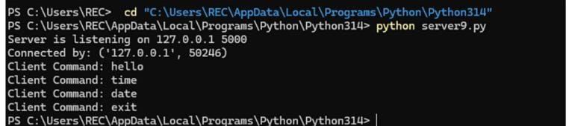

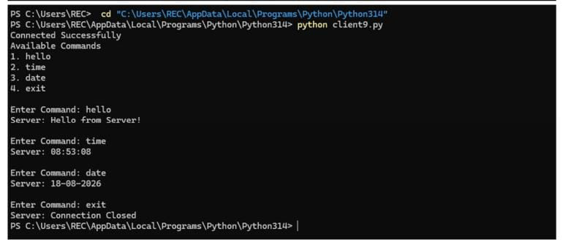

RESULT:
Thus program is written to create reverse shell using TCP sockets

